Abermaw Barmouth Community Council

Audit for the year ended 31 March 2016

We confirm that, in relation to Abermaw Barmouth Community Council, as at the statutory publication date of 30 September 2016 no audit opinion has as yet been issued in relation to the Accounting Statements for the year ended 31 March 2016.

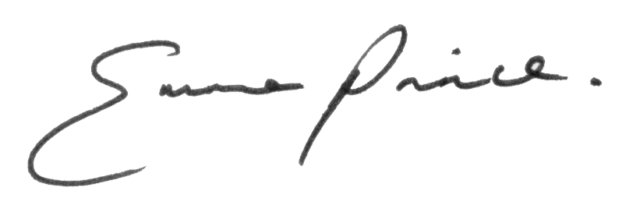

For and on behalf of BDO LLP

